Postcode Application Design Document

(Version 1.0.0)

Table of Contents

Version history 3

Architecture 4

Application flow 5

Authorization 7

Data storage 9

Data persistence 10

Validation 11

Assumptions 12

Technical stack and tools 13

Appendix 15

Reference 15

# Version history

|  |  |  |  |
| --- | --- | --- | --- |
| Editor | Version | Description | Remark |
| Patrick Cheung | 1.0.0 | Initial release |  |

# Architecture

The Postcode Application acts as a Resource Server hosting APIs related to postcode information.

The application allows unrestricted access to general query type endpoints, but requires secured access to endpoints which perform updates to the system.

There are 2 main components in the setup, the controller (PostcodeController) and the service (PostCodeService).

The PostcodeController is the entry point to the incoming API calls. The dispatcher servlet allocates the call to the relevant handling method based on the URL pattern. Once entered the method, the controller will then delegate the actual handling to the service.

The PostCodeService is where the actual business logic is performed, where it will initiate a data query or update. A data-access-object (DAO) PostcodeRepository is created to perform the actual persistence. When a result is received from the DAO operation, it will in turn provide the result back to the controller, which will then be sent back to the client application.

## Application flow

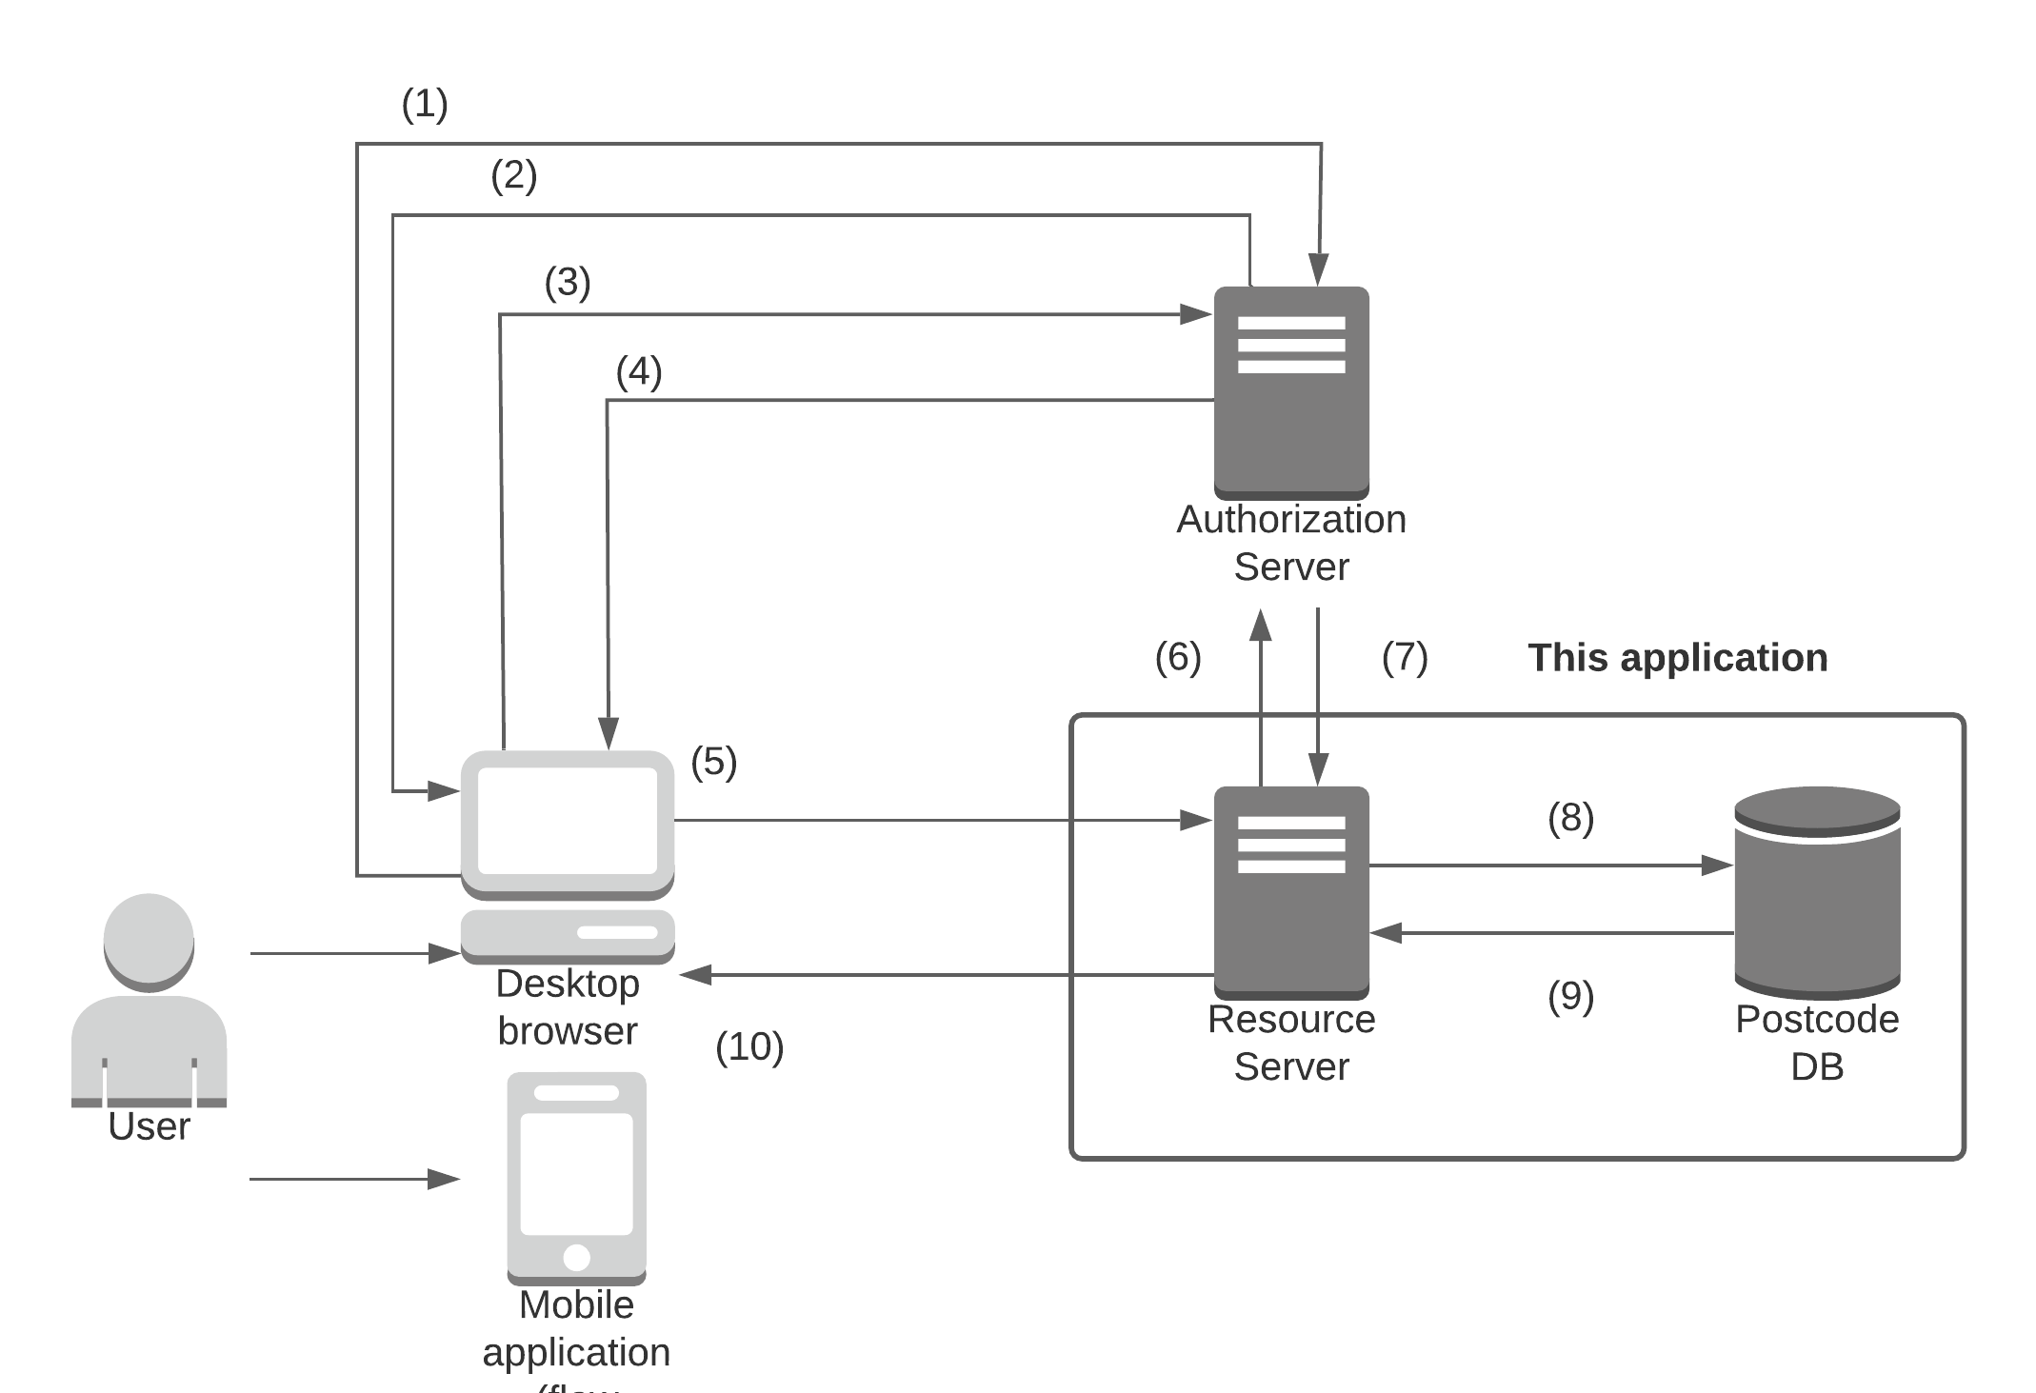

A typical flow of events would be similar as below. **Bolded** steps are the operations performed by the resource server.

Note that the following components are out of scope of this application

* Client application
* Authentication server and/or identity provider.

(1) Client applications receive request from user to access API endpoint on resources server. If the endpoint does not require authentication, it will directly proceed to call the endpoint (i.e. go to (5)) without the need of access token.

If the endpoint requires secure access, the client application will trigger the OAuth2 authorization code flow. It will ask the authorization server (Okta in our case) for an authorization code.

If the user is not yet authenticated on the browser, Okta will show the user login page for user to login.

(2) If the credentials are correct, the authorization server returns an authorization code.

(3) The client application asks the authorization server for an access token.

(4) The authorization server returns an access token (JWT token)

(5) The client application continues to call the desired API endpoint, including the JWT token in the request.

**(6) The resource server gets a list of public keys from the authorization server to check the validity of the token.**

**(7) The authorization server returns a list of public keys.**

**(8) The resource server carries out the actual API logic, querying/updating the database.**

**(9) The resource server receives query/update results from the database.**

**(10) The resource server returns the operation results to the client application.**

## Authorization

The application is secured by Spring Security as a resource server. By default, all requests to the application requires authorization.

For the endpoints which only fetches information (e.g. get a list of suburbs matching the postcode), the path to the API endpoint is whitelisted such that it does not require authentication.

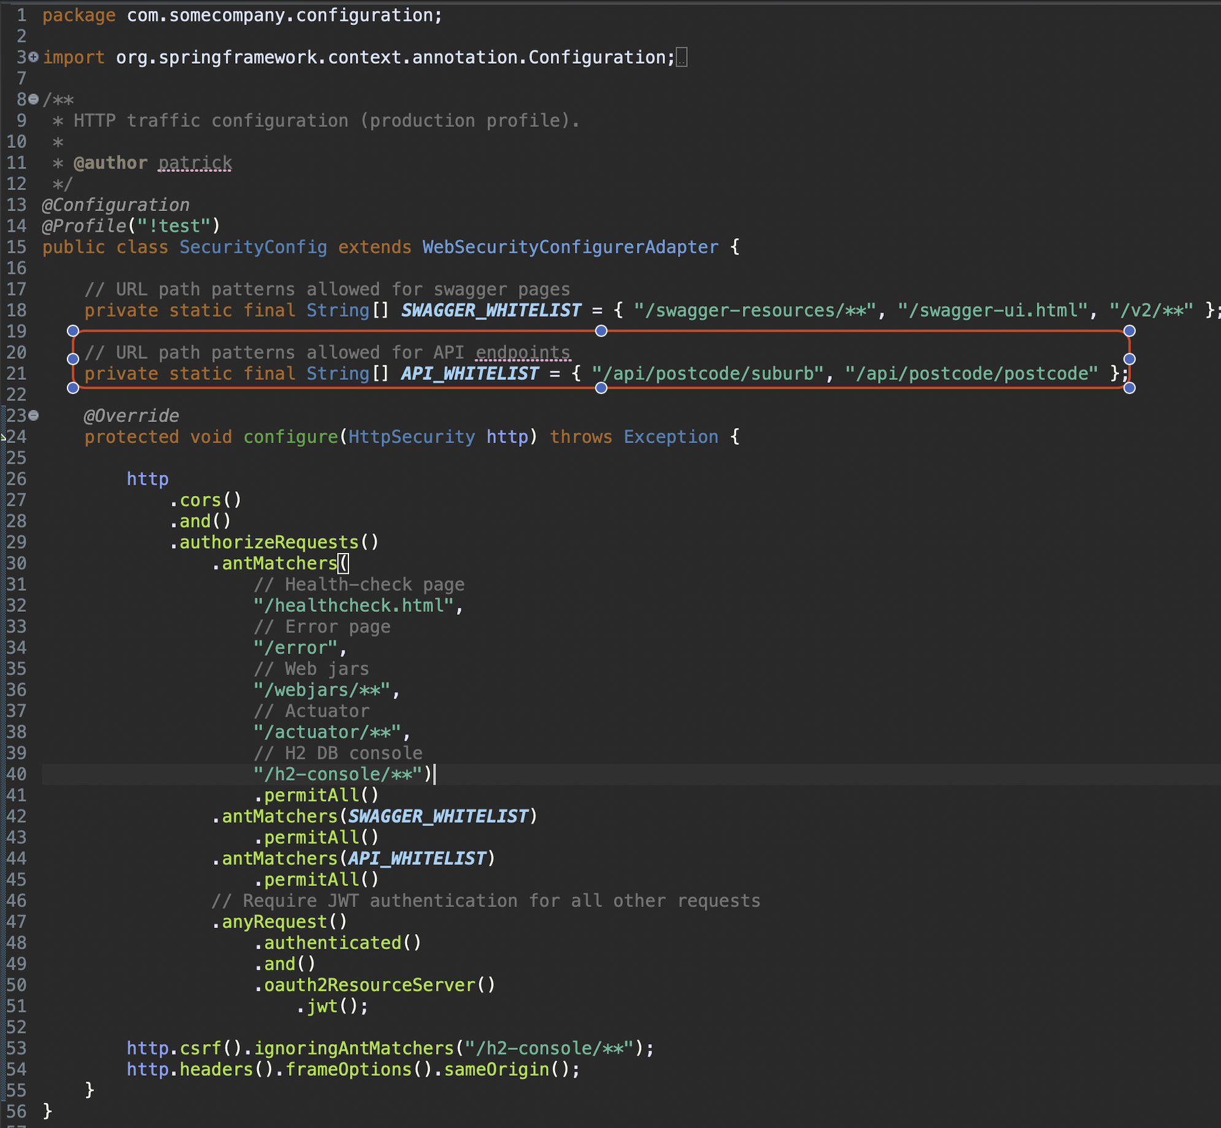

For the endpoints which updates the database, client application will need to include a JWT token obtained from the authentication server.

If the JWT token is not present, it will be blocked before allowed into the business logic.

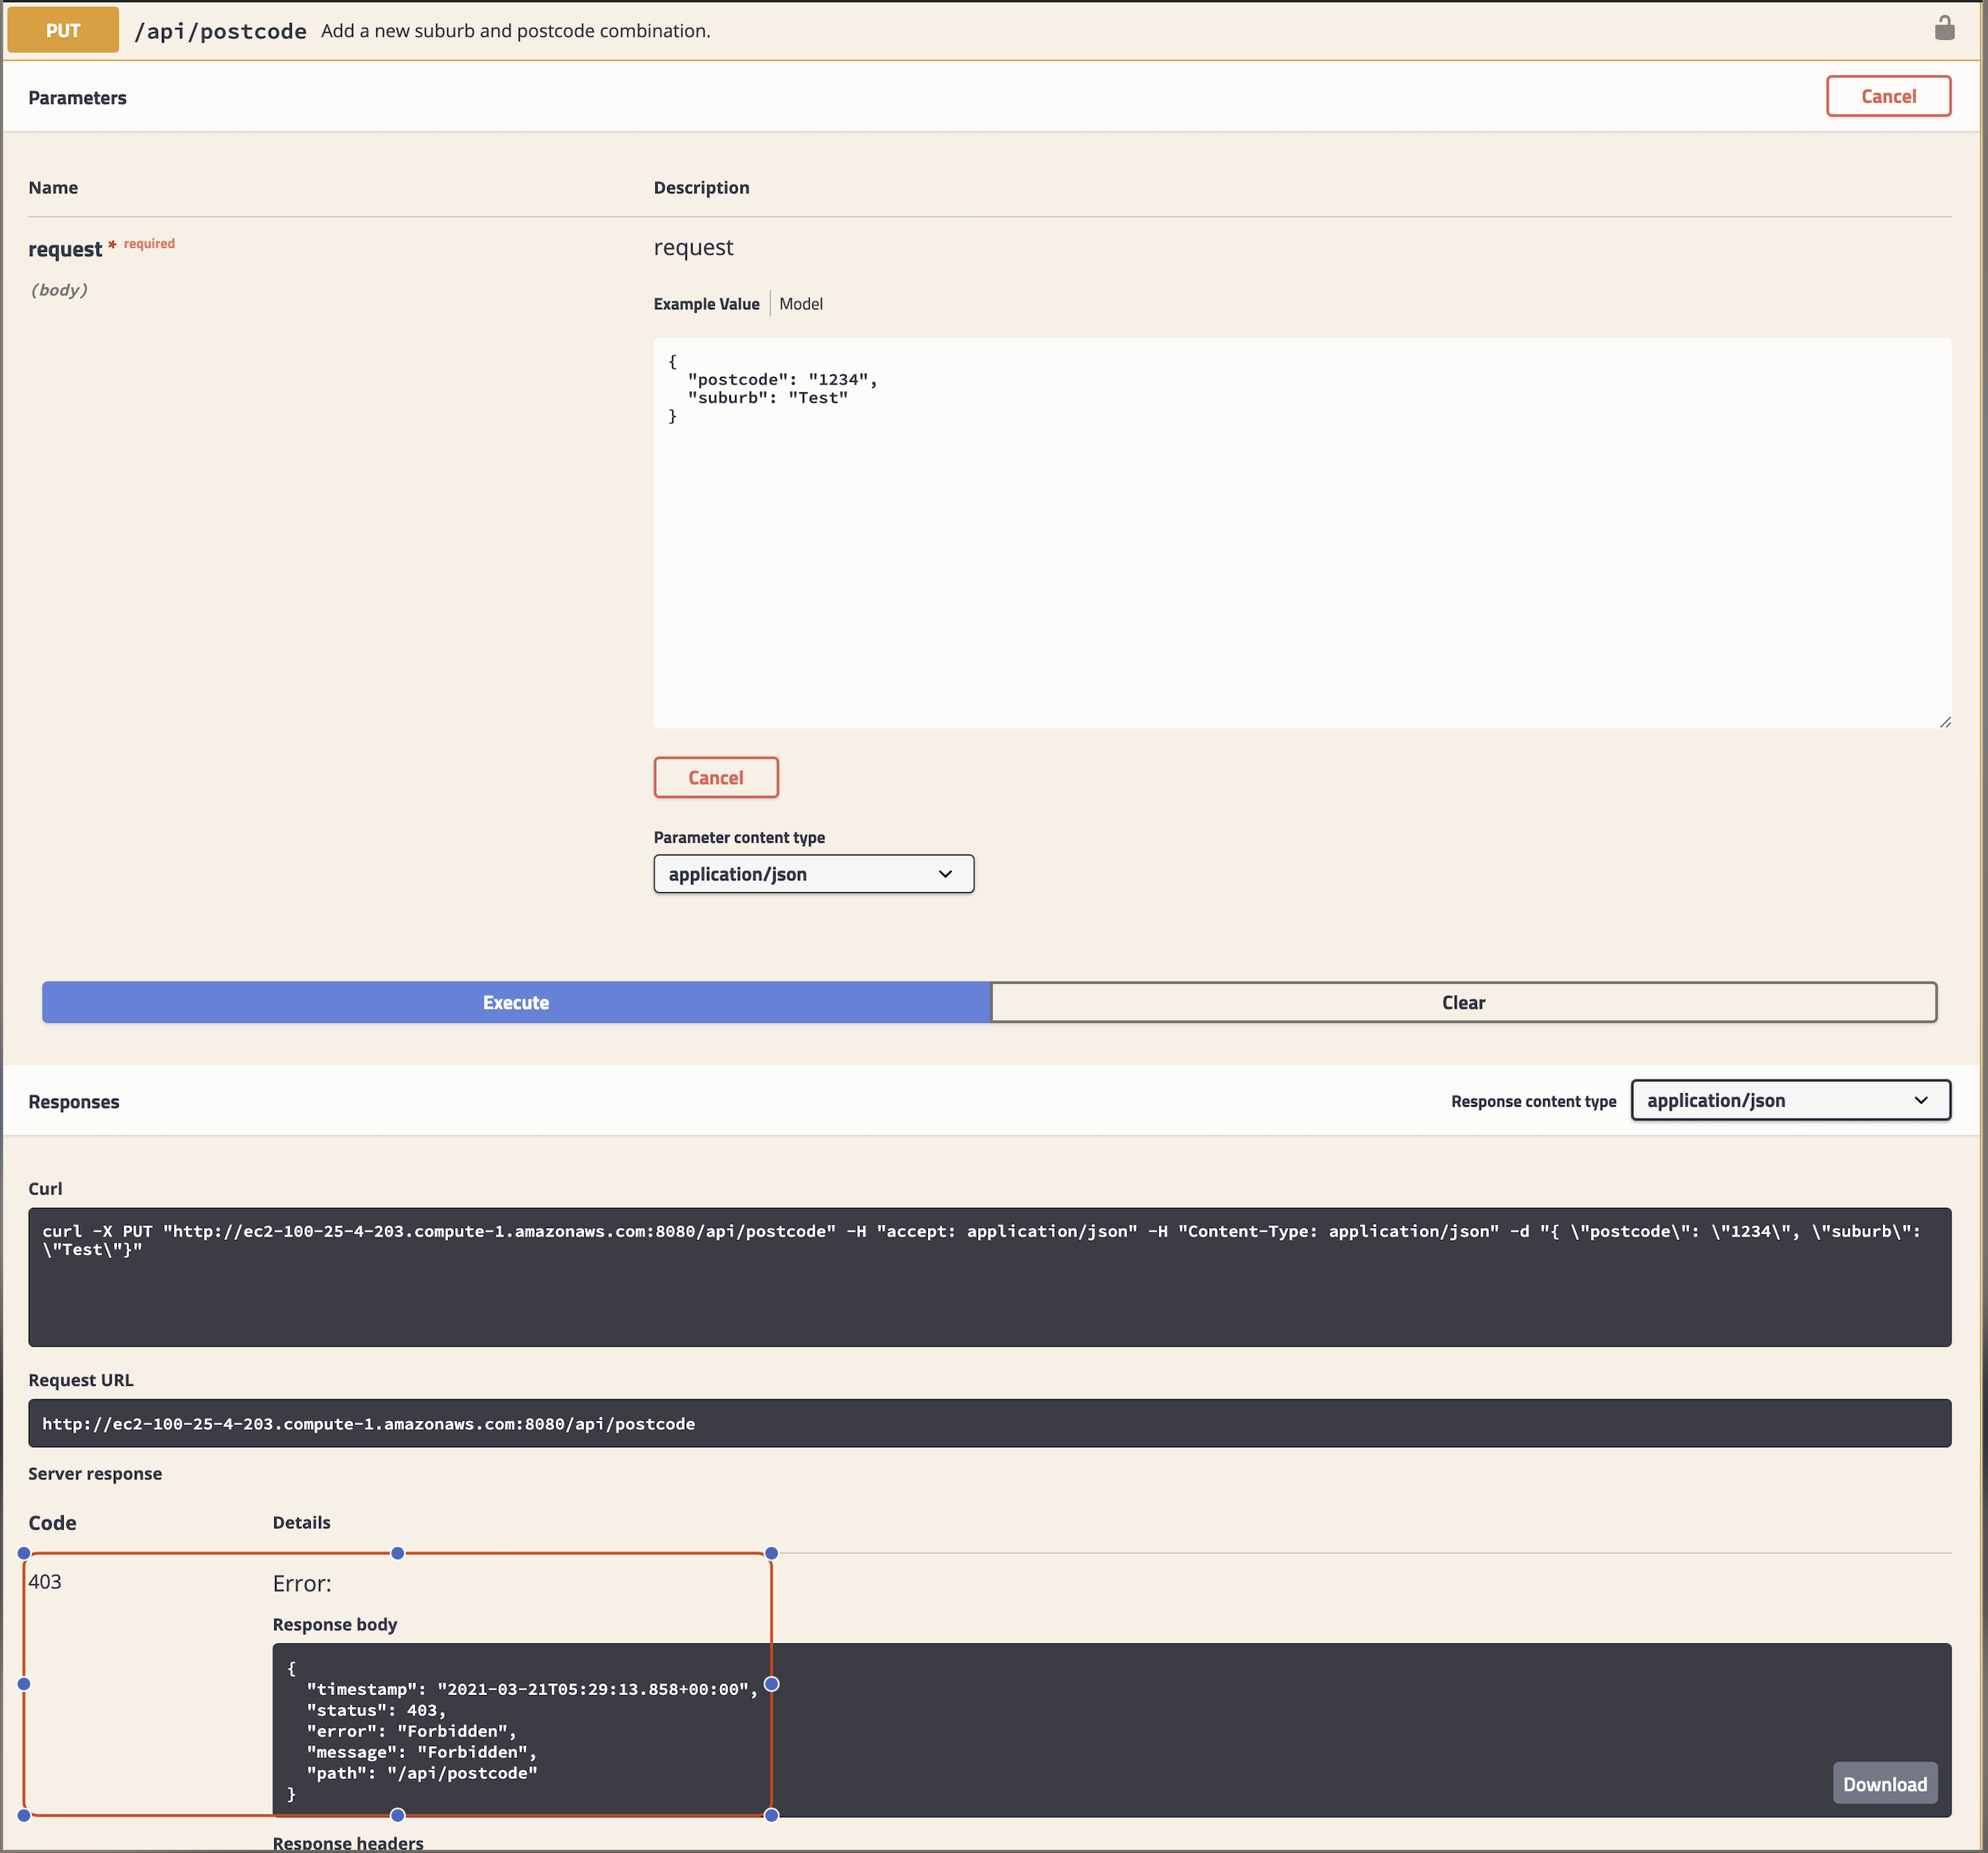

Also note that this application assumes the authorization is delegated to Okta, which is a well-known identity provider.

## Data storage

The H2 in-memory database is used as the data storage due to its compact size.

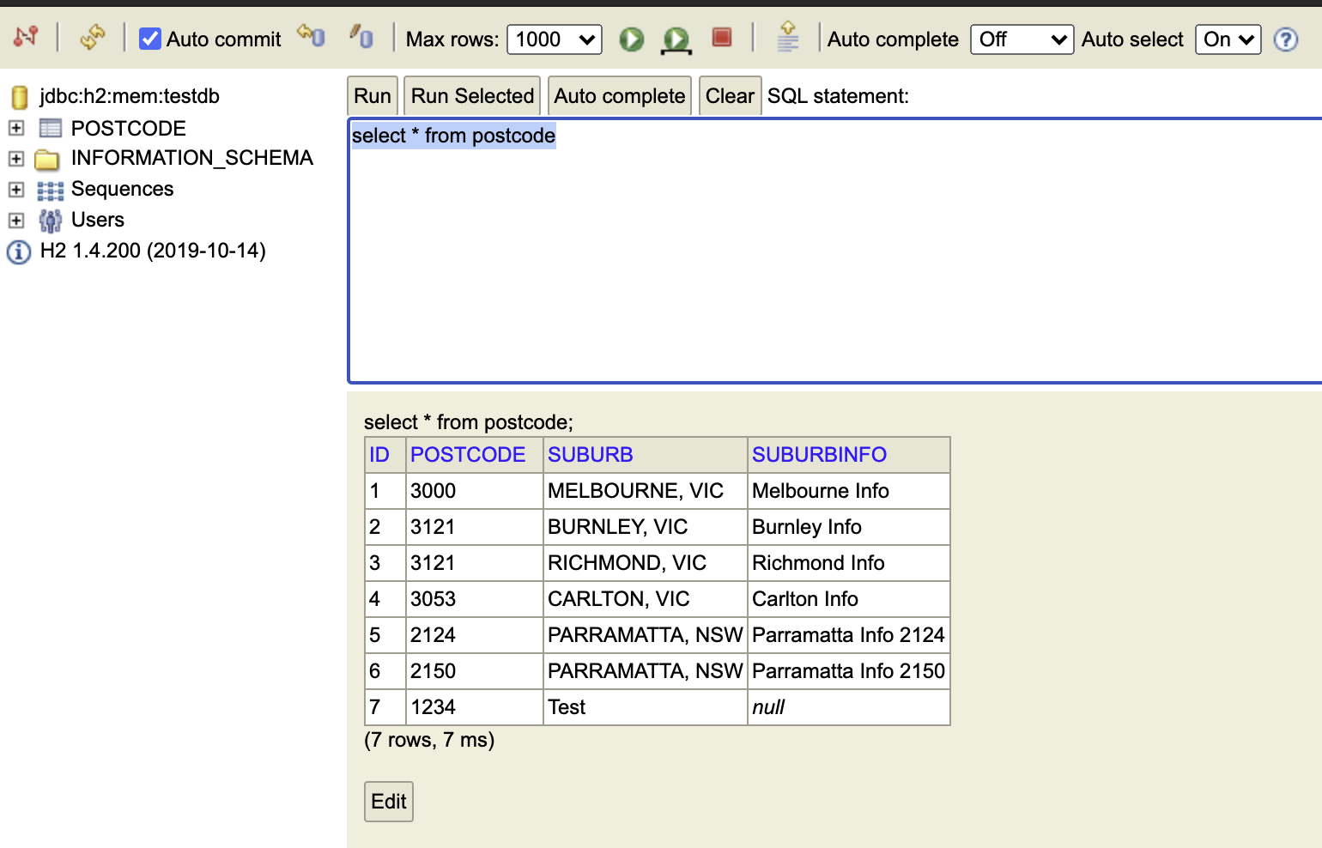

Tables and data are configured to be erased on system shutdown considering the demonstration nature of the application, but the behaviour can be changed.

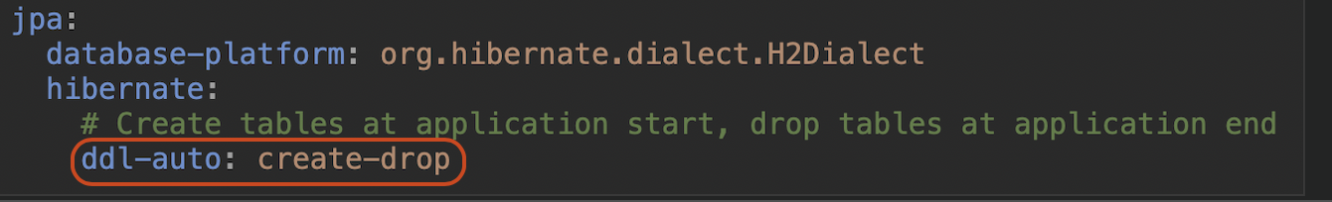

We can also switch to another database by changing the datasource.

## Data persistence

Data persistence is performed by Hibernate under Spring Data. We make use of the JpaRepository which provides generic CRUD operations for interaction with the database.

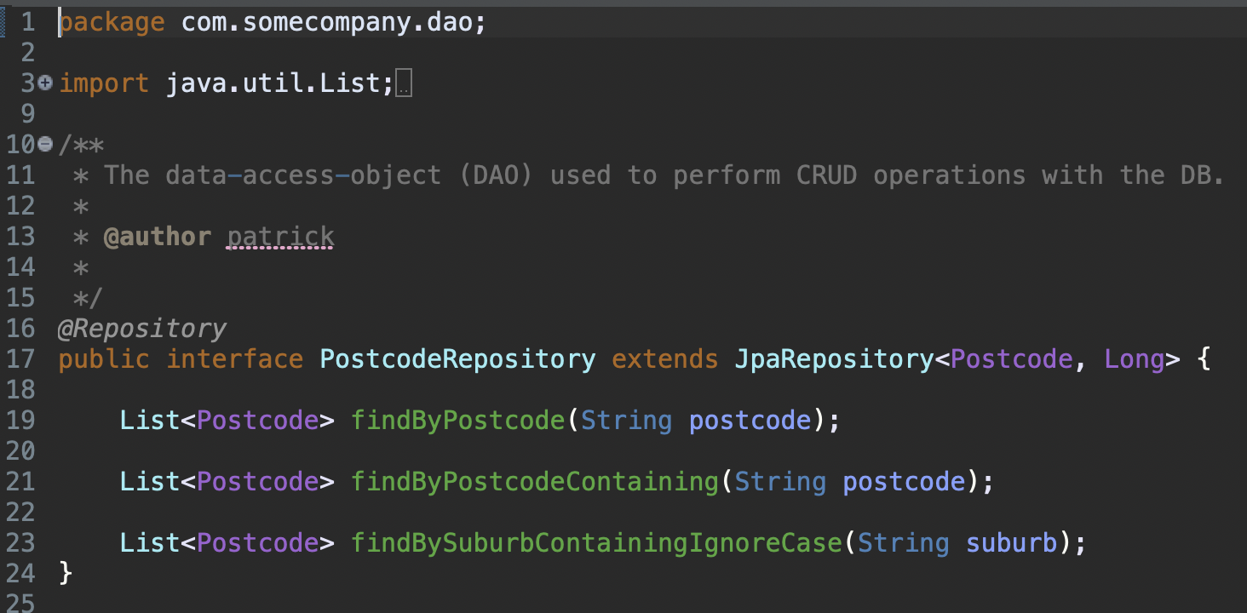

It can provide fine-grained operations based on the method name. For example, adding "Containing" will result in a SQL having the matching wilcard pattern (e.g. ...LIKE %param%),

and "IgnoreCase" will result in a SQL ignoring case on the parameter.

## Validation

Validation is performed by the javax.validation package on 2 areas.

If the request is query request (e.g. GET), the parameter will be validated in the controller level before entering the actual service. Any error arised will be caught, reformatted to custom validation error, and returned to client application.

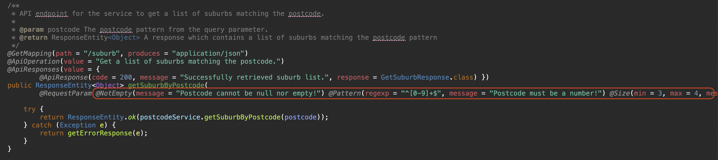

If the request is an update request (e.g. PUT), data will be fetched from the request body to create a bean (Postcode object) which will be used for persistence. if the passed-in values does not fulfill the requirement specified by the bean, bean validation will fail. Again, the error will be reformatted to custom validation error, and returned to client application.

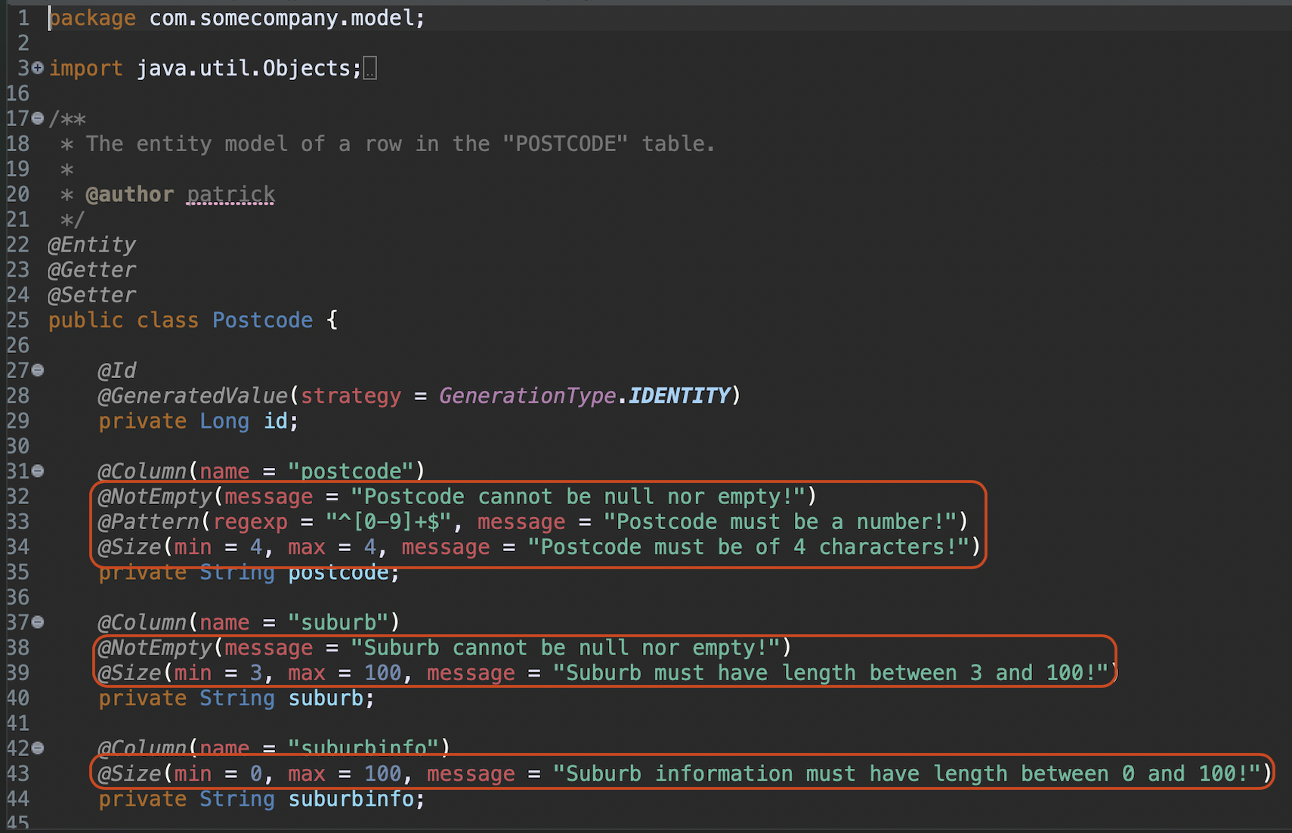

# Assumptions

The following assumptions are made for the application

* Client application is not in scope
* Authentication server is not in scope
* The application uses an in-memory database
* One suburb can have many postcodes, and one postcode can resort to many suburbs
* 2 entries are the same if they have the same postcode and suburb (case-insensitive). For example, user will not be able to add a combination {"postcode": "1234", "suburb": "Test"} if the DB already has a record with postcode="1234" and suburb="test"

# Technical stack and tools

|  |  |  |
| --- | --- | --- |
| Component | Version | Description |
| Java Development Kit (JDK) | 11.0.9 (for local build and run),  Docker image adoptopenjdk/openjdk11:alpine-jre (for docker run) | The java runtime of the application |
| Maven | 3.6.3 (for local build), Docker image maven:3.6.3-jdk-11 (for docker build) | For compilation, uses JDK above |
| Spring Boot | 2.4.4 | The Spring Boot Container |
| Dependencies | | |
| spring-boot-starter-actuator | Determined by parent | Provides insights on endpoints |
| spring-boot-starter-oauth2-resource-server | Determined by parent | Secures the application with Spring Security as a resource server |
| spring-boot-starter-security | Determined by parent | Secures the application with Spring Security |
| spring-boot-starter-web | Determined by parent | For HTTP request/response support |
| h2 | Determined by parent | Provides in-memory H2 DB |
| spring-boot-starter-data-jpa | Determined by parent | Provides JPA support |
| spring-boot-starter-validation | Determined by parent | Provides validation support on request params and beans |
| springfox-swagger2 | 2.9.2 | Provides Swagger support |
| springfox-swagger-ui | 2.9.2 | Provides Swagger support |
| spring-boot-devtools | Determined by parent | For development, support live reload of server |
| lombok | Determined by parent | Provides getters/setters to entity/model class properties, and provides slf4j support for logging |
| spring-boot-starter-test | Determined by parent | Provides JUnit support |
| spring-security-test | Determined by parent | Provides testing support for Spring Security |
| reactor-test | Determined by parent | Provides testing support for Spring WebFlux |
| Docker | 20.10.5 (for local build and run),  19.03.13-ce (for cloud server run) | For building docker image, running docker image and pushing to repository |
| AWS EC2 instance | Amazon Linux 2 AMI (HVM), SSD Volume Type - ami-0533f2ba8a1995cf9 (64-bit x86) / ami-01714cd923447b104 (64-bit Arm)  Instance type: t2.micro | For hosting the application on cloud server |

# Appendix

## Reference

|  |  |
| --- | --- |
| Website | Description |
| https://dzone.com/articles/implement-oauth-20-easily-with-spring-boot-and-spr | Provides information on implementing a secured resource server |